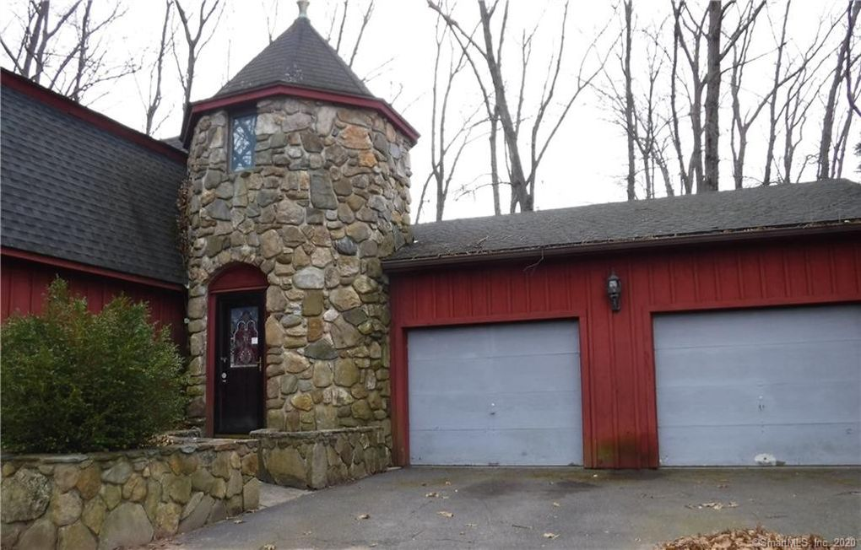

Property Details for 8 Sullivan Farm Rd

Public Records

Beds: 3Rooms: 5House size: 2,136 sq ftStories: 2Lot size: 30056Garage: Attached GarageHeating: RadiantCooling: UnknownConstruction: Wood FrameYear built: 1981Year renovated: 2001Property type: Single familyStyle: ColonialDate updated: 04/24/2020Fireplace: Wood Stove

Est. $147,300

Property Overview - Colonial style home. Lots of great possibilities to make this your own. Stone fireplace in living room, spacious kitchen ready to finish.First floor master bedroom, first floor laundry room. Two car garage, Wooded lot and patio, shed in back.